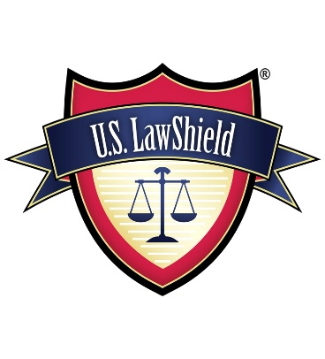
U.S Law Shield
30-Day Free Trial

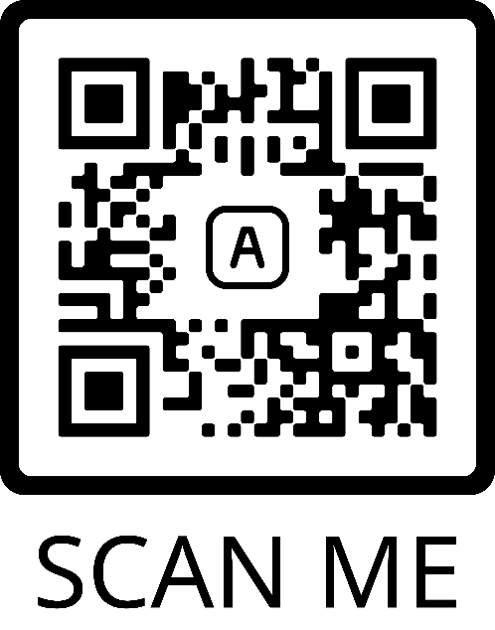
Promo Code: sbft
(Please Scan QR code and download app prior to class)
*You must put the promo code in to get the free 30-day trial and waive the start-up fee
* Final Step: Confirm email and your membership card will be (Red/White/Blue)

